

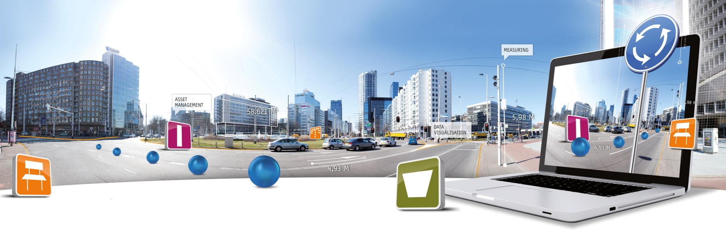

**GlobeSpotter for ArcGIS Desktop User Manual**

Datum: 22 januari 2014

CycloMedia Technology B.V. | **T** +31 (418) 556100 | **E**: [info@cyclomedia.com](mailto:info@cyclomedia.com)

# Index

Index 2

1. Installation 3

2. How to use GlobeSpotter for ArcGIS Desktop 6

2.1 Show Cyclorama images 6

*2.1.1* *Show recent Cyclorama layer* 6

*2.1.2* *Show historical Cyclorama layer* 6

*2.1.3* *Open a Cyclorama image* 7

2.2 Show Vector data 9

2.3 Measurement 10

*2.3.1* *Standaard measurement – Point measurement* 10

*2.3.2* *Standaard measurement – Line / Surface measurement* 12

*2.3.3* *Smart click measurement – Point measurement* 14

*2.3.4* *Smart click measurement – Line / Surface measurement* 16

*2.3.5* *Import a measurement back in a Cyclorama* 18

# 1. Installation

To install GlobeSpotter for ArcGIS Desktop you must perform the following steps:

1. Check if ‘Adobe Flash Player’ is installed on your machine. If ‘Adobe Flash Player’ is not, installed, install ‘Adobe Flash Player’.
2. If you have installed a previous version of GlobeSpotter for ArcGIS Desktop, first delete the previous version:
   1. Start ArcMap.
   2. 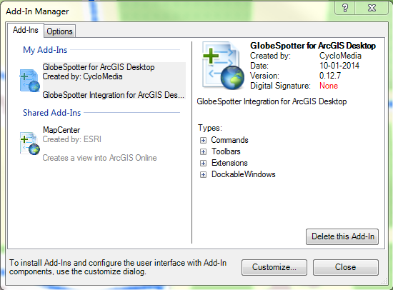Customize -> Add-In Manager (Figure 1)
   3. Select the ‘GlobeSpotter for ArcGIS Desktop’ Add-In and click on the button: <Delete this Add-In>

Figure 1: Add-In Manager

* 1. 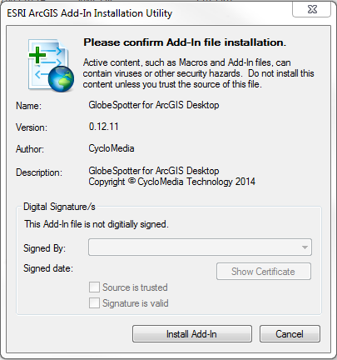Exit ArcMap

1. Double-click the GlobeSpotter for ArcGIS Desktop add-In and select <Install Add-In> to install the Add-In. (Figure 2)

Figure 2: GlobeSpotter for ArcGIS Desktop Add-In installation

1. Start ArcMap.
2. 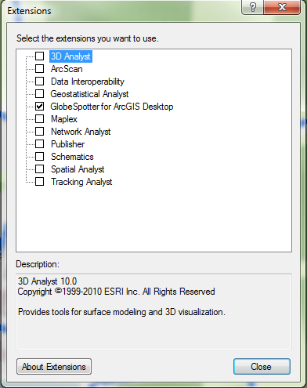Select the menu: Customize -> Extensions. (Figure 3).
3. Checkmark: ’GlobeSpotter for ArcGIS Desktop’ and you will now get the ‘GlobeSpotter for ArcGIS Desktop’ Agreement. (Figure 4)

Figure 3: Extensions menu

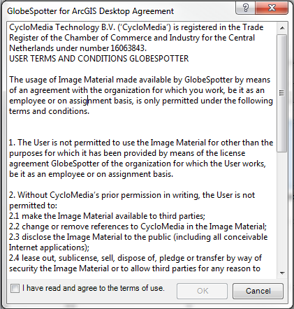

Figure 4: Agreement form

1. Checkmark: ‘I have read and agree to the terms of use’ and click on ÓK’. Now you can close the extensions menu.
2. Then select the GlobeSpotter toolbar: Customize -> toolbars -> GlobeSpotter. (Figure 6)
3. 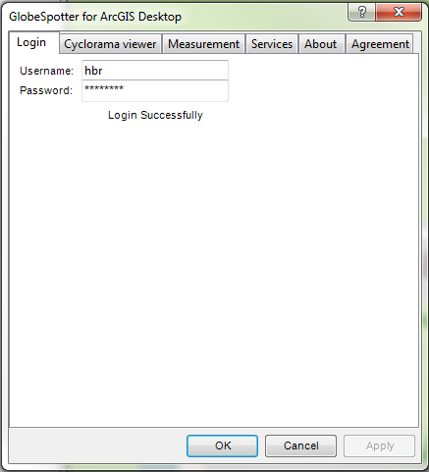Select the ‘GlobeSpotter for ArcGIS Desktop’ icon (Figure 5) of the Cyclorama toolbar. You get the ‘GlobeSpotter for ArcGIS Desktop’ form. (Figuur 7)

Figure 5: The selected 'GlobeSpotter for ArcGIS Desktop' icon

Figure 6: GlobeSpotter toolbar

Figuur 7: The GlobeSpotter for ArcGIS Desktop form

1. Enter your username and password and press: <Apply>
2. If you see ‘Login Successfully’, you are logged in.
3. Now you are ready for use the GlobeSpotter for ArcGIS Desktop Add-In.

# 2. How to use GlobeSpotter for ArcGIS Desktop

## 2.1 Show Cyclorama images

### *2.1.1 Show recent Cyclorama layer*

You have to do these steps to show the recent Cyclorama layer in the map:

1. Select in the GlobeSpotter toolbar: ‘Add recent cyclorama layer’(Figure 8).
2. 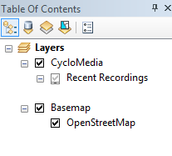In the 'Table of contents – layers’ screen appears a 'CycloMedia - Recent Recordings' layer (Figure 9).

Figure 8: The selected 'Add Recent Cyclorama Layer’ icon

1. Zoom in on the map and if you have reached a zoom level of 1:2000, you will see dots on the map. (With the condition that there are recordings in that area)

Figure 9: The CycloMedia - Recent Recordings Layer

### *2.1.2 Show historical Cyclorama layer*

You have to do these steps to show the historical Cyclorama layer in the map:

1. Select in the GlobeSpotter toolbar: ‘Add historical cyclorama layer’(Figure 10).

Figure 10: The selected 'Historical Cyclorama Layer' icon

1. 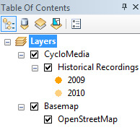In the 'Table of contents – layers’ screen appears a 'CycloMedia – Historical Recordings' layer (Figure 11).
2. Zoom in on the map and if you have reached a zoom level of 1:2000, you will see dots on the map. (With the condition that there are recordings in that area)

Figure 11: The CycloMedia - Historical Recordings Layer

1. The date range of the recordings can be changed with the ‘CycloMedia Recording History’ form. Select the ‘CycloMedia Recording History’ form in the GlobeSpotter toolbar. (Figuur 12)

Figuur 12: The selected CycloMedia recording History form

1. You can change the date range in this form. (Figure 13)

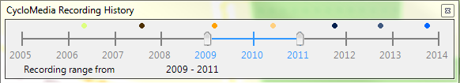

Figure 13: CycloMedia Recording History

### *2.1.3 Open a Cyclorama image*

You have to do these steps to open a Cyclorama image:

1. Select the ‘Cyclorama viewer’ tab of the GlobeSpotter for ArcGIS Desktop form. (Figure 14)
2. Select the special reference which the viewer must use.
3. Select the max number of viewers which can be opened at the same time. The default value is three viewers.
4. Some areas are driven with additional cameras. These detailed images can be made visible with the detail images checkmark.
5. Press <Apply> and the changes take effect.
6. Select the ‘Open location tool’ in the Cyclorama toolbar (Figure 15).
7. 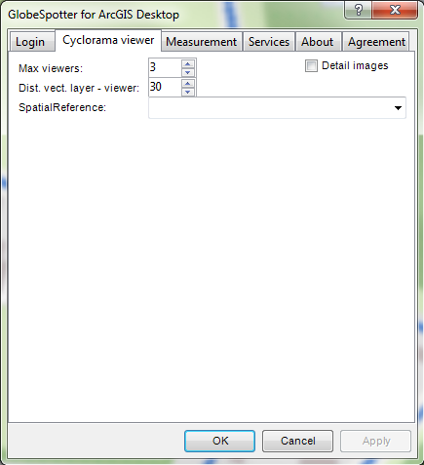Click on a dot and the corresponding cyclorama opens (Figure 16).

Figure 14: Cyclorama viewer tab

Figure 15: The selected 'Open location tool'

1. Click on another dot and a second corresponding cyclorama opens (Figure 16).
2. Right click on the Recent or Historical Recording layer and the feature layer context menu appears. (Figure 18).
3. 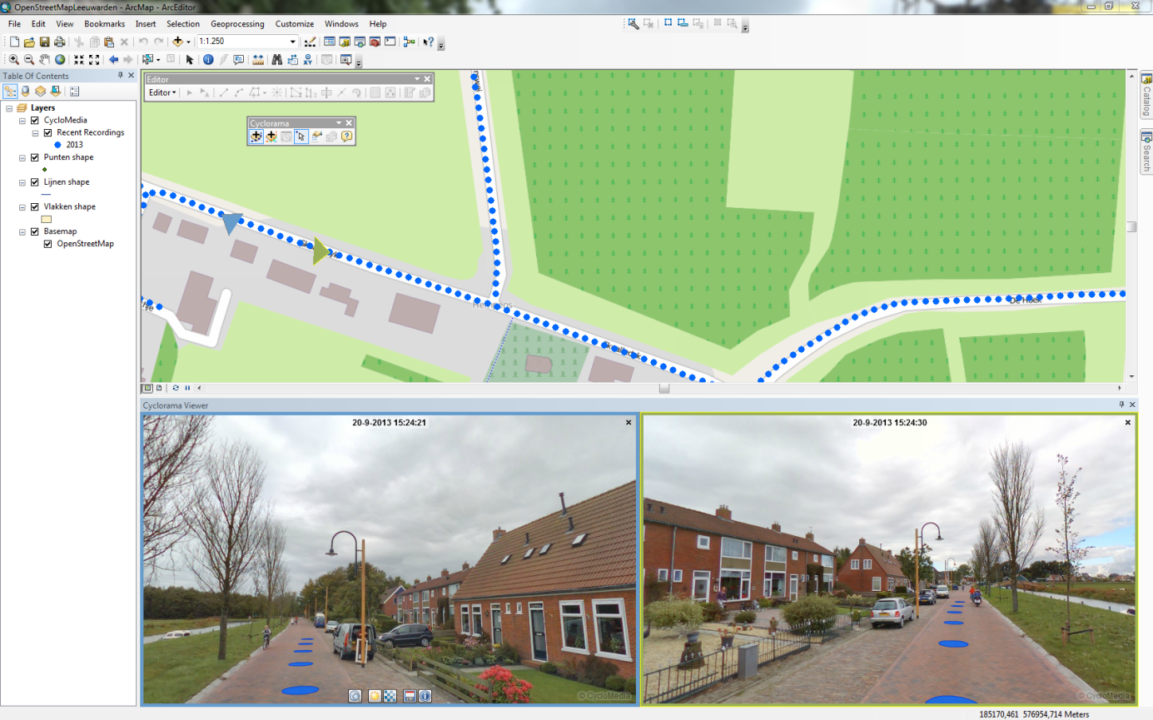With The 'Show in Cyclorama' button, the recording points in the Cyclorama can be turned on or off.

Figure 16: GlobeSpotter for ArcGIS Desktop with 2 open cycloramas

## 2.2 Show Vector data

1. Add vector data to the map (Points, lines or polygons), vector data can be like:
   * Shape files
   * ArcSDE
   * Personal MDB
   * File GDB
2. 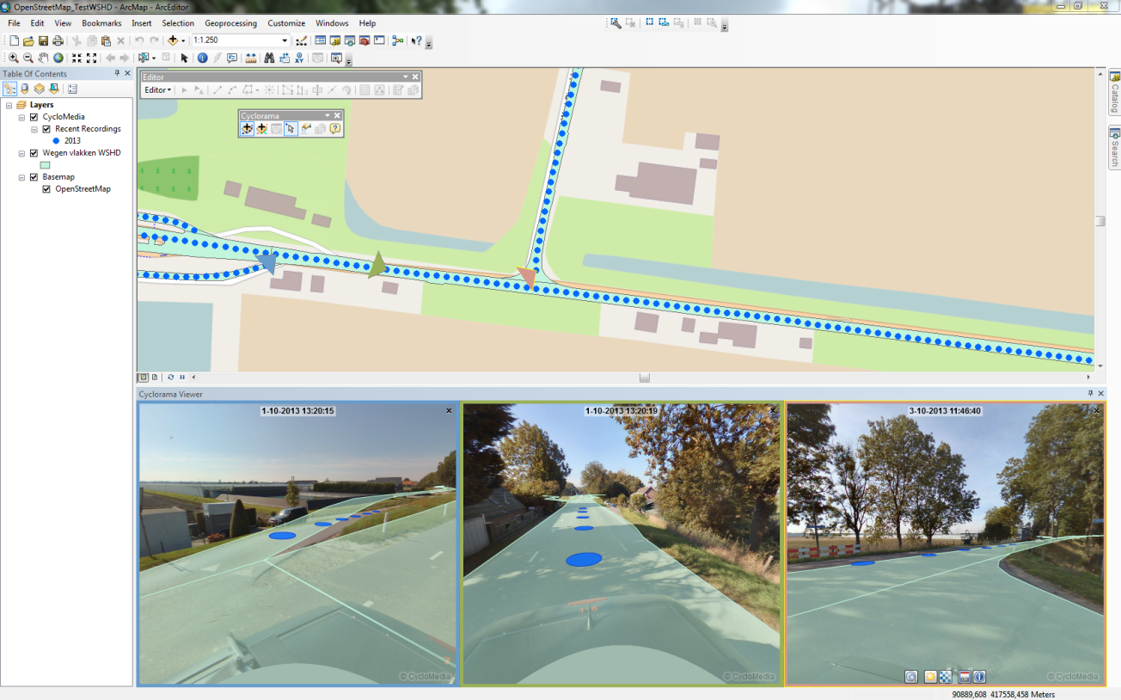Open a cyclorama (Figure 17)

Figure 17: Show vector data

1. 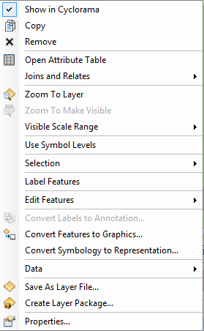Right click on the vector layer and the feature layer context menu appears (Figure 18)
2. With The 'Show in Cyclorama' button, the vector layer in the cyclorama can be turned on and off.
3. The distance around the images which the vector layer data is included in the cyclorama can be set in the ‘GlobeSpotter for ArcGIS Desktop – Cyclorama viewer’ menu (Dist vect layer – viewer) (Figure 14). The default distance is 30 meters.

Figure 18: feature layer context menu

## 2.3 Measurement

Measurements are stored in vector data layers. Point, line or surface measurements are stored in point, line or polygon vector data layers. The following sections explain in detail the various types of measurements:

* + ***2.3.1 Standaard measurement – Point measurement***
  + ***2.3.2 Standaard measurement – Line / Surface measurement***
  + ***2.3.3 Smart click measurement – Point measurement***
  + ***2.3.4 Smart click measurement – Line / Surface measurement***

### *2.3.1 Standaard measurement – Point measurement*

1. Add a point vector data layer to the map where you want to add the measurement.
2. Open two or more images which the object is visible what should be measured.
3. 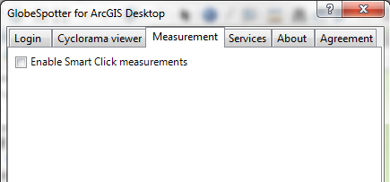Disable smart click measurement in the ‘GlobeSpotter for ArcGIS Desktop – Measurement’ menu. (Figure 19)
4. 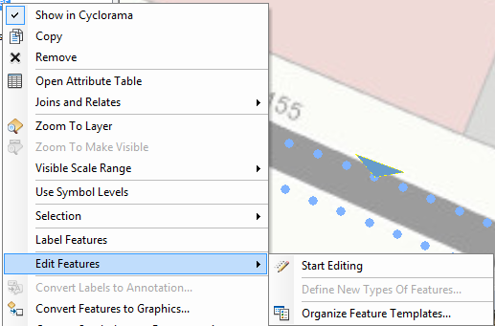Right click on the point vector layer and select: ‘Edit Features -> Start Editing’

Figure 19: Disable smart click measurement

(Figure 20)

Figure 20: Edit features

1. 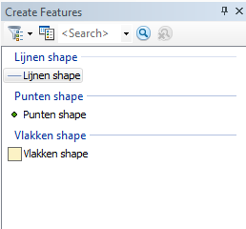Select the point layer in the Create Features form to start a point measurement. (Figure 21)
2. 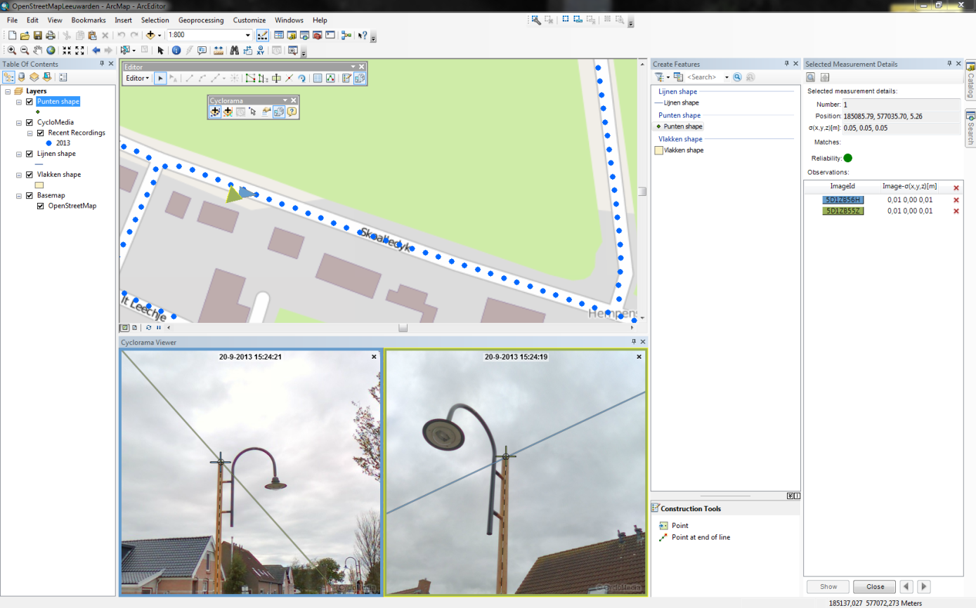Select the point you want to measure in the first image.

Figure 21: Create Features

1. Select the point you want to measure in the second image. (Figure 22)

Figure 22: Point measurement (no smart click)

1. 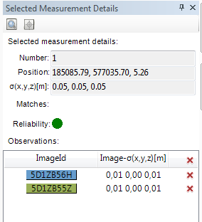The selected measurement details form contains information about the measurement. (Figure 23)

Figure 23: Selected measurement details form

1. The GlobeSpotter toolbar contains a icon for make the selected measurement details form visible / invisible. (Figure 24)

Figure 24: The selected measurement details icon

1. It is possible now for remove observation points or to add more observation points.
2. If you want to add more observation points, open a new image and select in that image the point you want to measure.
3. If you are finished, Click the <Close> button down the ‘Selected Measurement Details’ form. (Figure 25)

Figure 25: The selected measurement details buttons

1. The measurement point is now added, if you want, you can now measure more points at the same way.
2. 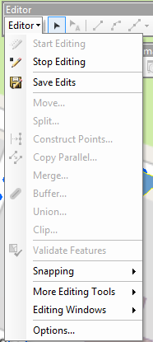If you are finished with measurement, you can save the edits to the vector layer. (Figuur 26)

Figuur 26: Menu for save and stop editing

### *2.3.2 Standaard measurement – Line / Surface measurement*

1. Add a line or a polygon vector data layer to the map where you want to add the measurement.
2. Open two or more images which the object is visible what should be measured.
3. Disable smart click measurement in the GlobeSpotter for ArcGIS Desktop Options – Measurement menu. (Figure 19)
4. Right click on the line or polygon vector layer and select: ‘Edit Features -> Start Editing’ (Figure 20)
5. Select the line or polygon layer in the Create Features form to start a line or a surface measurement. (Figure 21)
6. Select the first point you want to measure in the first image.
7. 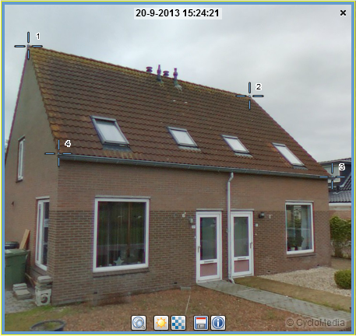Then you select the second and the third point you want to measure, until you have done all the points you want to measure in the first image. (Figure 27)
8. Then you select step by step all the points of the measurement in the second image. (Figure 30)

Figure 27: select step by step all the points in the first image

1. The measurement is now complete. If you want to edit some measurement points, click the <Edit> button down the ‘Selected Measurement Details’ form. (Figure 28)
2. You can now move through the measurement points with the ‘<’ and the ‘>’ buttons.

Figure 28: The edit button for edit the measurement

1. You can add or remove observation points for a selected measurement. (Figure 23)
2. If you want to go back to the measurement for add more measurement points or to finished measurement. Click the <Close> button down the ‘Selected Measurement Details’ form. (Figure 25)
3. 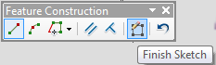Click on the "finish sketch" button of the "Feature Construction" menu to close the measurement. (Figure 29)

Figure 29: Feature Construction menu

1. 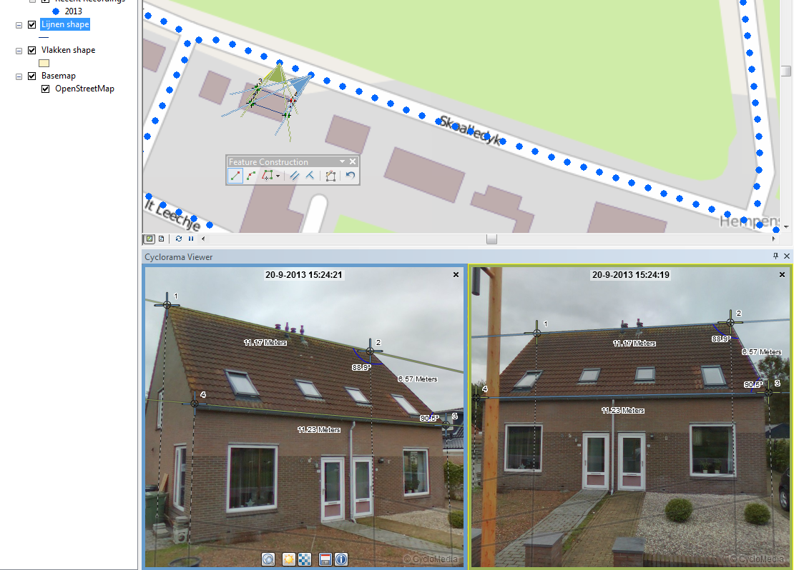 If you are finished with measurement, you can save the edits to the vector layer (Figuur 26)

Figure 30: After select the points in the second image, the measurement is complete

### *2.3.3 Smart click measurement – Point measurement*

1. Add a point vector data layer to the map where you want to add the measurement.
2. Open a image which the object is visible what should be measured.
3. 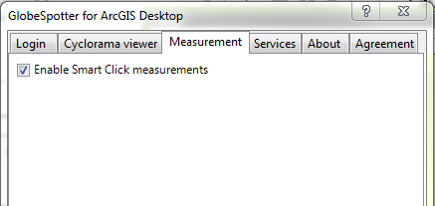Enable smart click measurement in the ‘GlobeSpotter for ArcGIS Desktop – Measurement’ menu. (Figure 31)

Figure 31: Enable smart click measurement

1. Right click on the point vector layer and select: ‘Edit Features -> Start Editing’ (Figure 20)
2. Select the point layer in the Create Features form to start a point measurement. (Figure 21)
3. Select the point you want to measure in the image. (Figure 32)

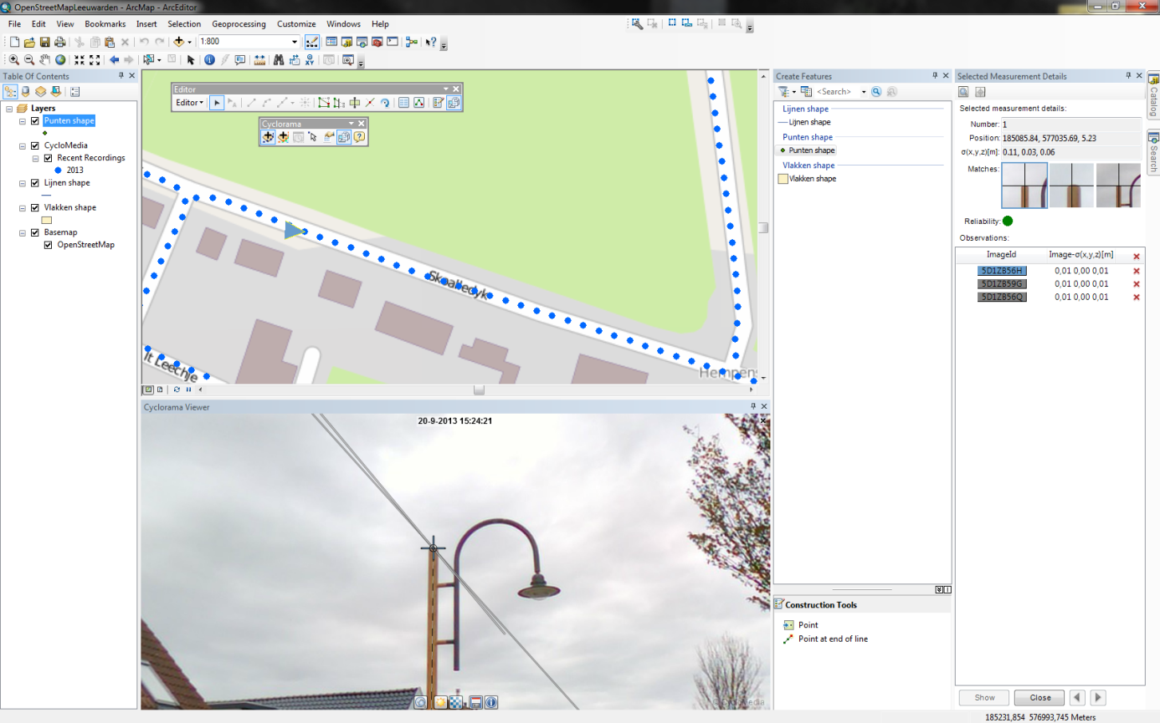

Figure 32: Point measurement (smart click)

1. 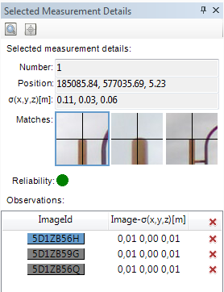The selected measurement details form contains information about the measurement. (Figure 33)

Figure 33: Selected Measurement Details form (Smart click)

1. 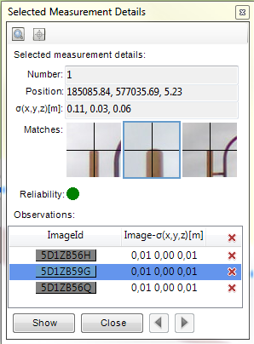You can check the other images which are found by smart click by clicking on the image and click on <Show>. (Figure 34)
2. It is now possible to change correspondence points found by smart click.

Figure 34: Check results found by smart click

1. It is also possible for add or remove observation points.
2. If you want to add more observation points, open a new image and select in that image the point you want to measure.
3. If you are finished, Click the <Close> button down the ‘Selected Measurement Details’ form. (Figure 34)
4. The measurement point is now added, if you want, you can now measure a second point at the same way.
5. If you are finished with measurement, you can save the edits to the vector layer. (Figuur 26)

### *2.3.4 Smart click measurement – Line / Surface measurement*

1. Add a line or a polygon vector data layer to the map where you want to add the measurement.
2. Open a image which the object is visible what should be measured.
3. Enable smart click measurement in the ‘GlobeSpotter for ArcGIS Desktop – Measurement’ menu. (Figure 31)
4. Right click on the line or polygon vector layer and select: ‘Edit Features -> Start Editing’ (Figure 20)
5. Select the line or polygon layer in the Create Features form to start a line or a surface measurement. (Figure 21)
6. Select the first point in the image which you want to measure. (Figure 35)

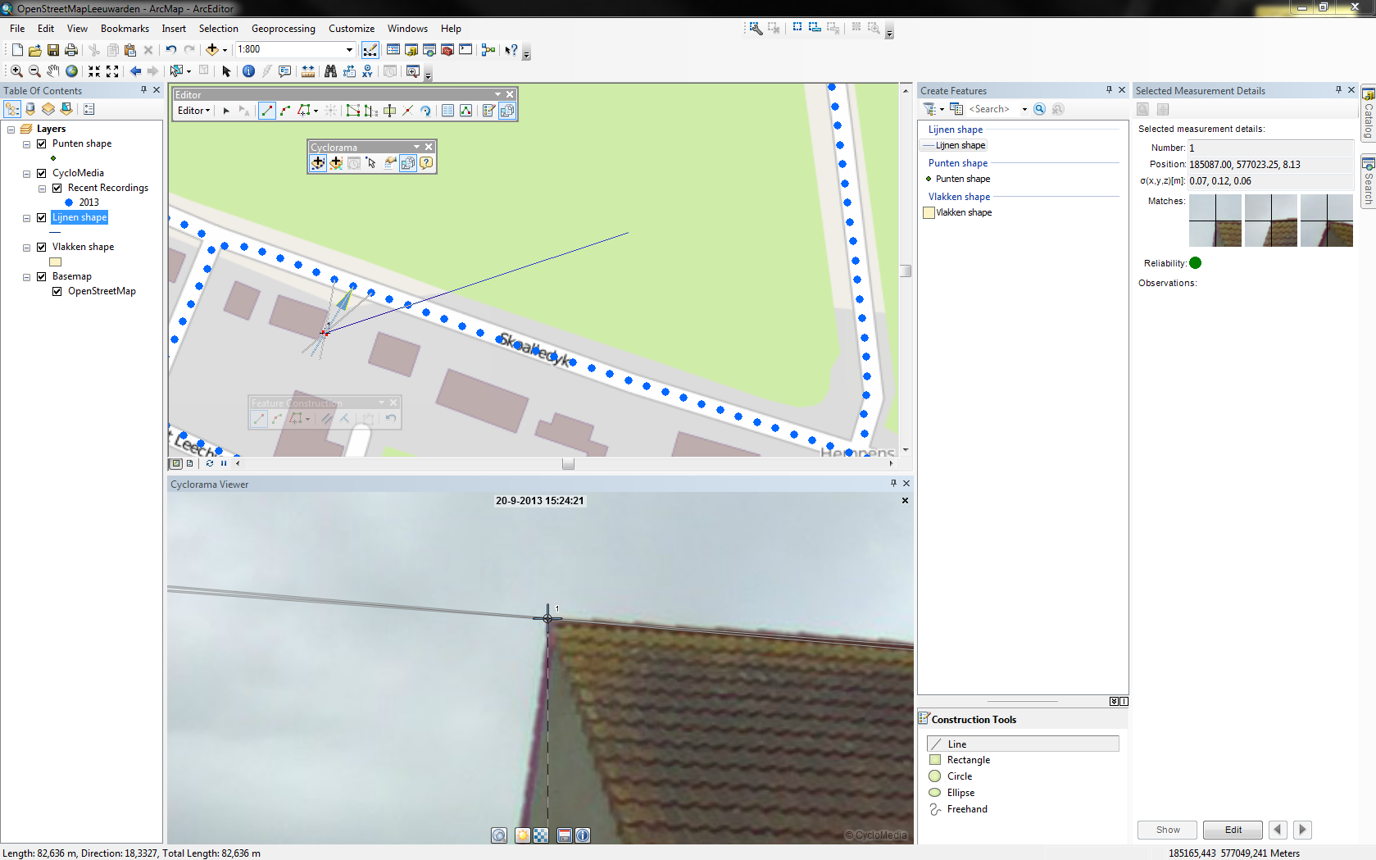

1. The selected measurement details form contains information about the measurement.

Figure 35: Line or polygon measurement after adding first point

(Figure 33)

1. If you want to edit or check some observation points, first click on the <Edit> button.
2. You can check the other images which are found by smart click by clicking on the image and click on <Show>. (Figure 34)
3. It is now possible to change correspondence points found by smart click.
4. It is also possible for add or remove observation points.
5. If you want to add more observation points, open a new image and select in that image the point you want to measure.
6. If you want to add more measurement points, first close the measurement point.
7. Then you select the second and the third point you want to measure, until you have done all the points you want to measure.
8. For each measurement point that you add, you must first check if it is good.
9. Click on the "finish sketch" button of the "Feature Construction" menu to close the measurement. (Figure 29)
10. If you are finished with measurement, you can save the edits to the vector layer (Figuur 26)

### *2.3.5 Import a measurement back in a Cyclorama*

You have to do these steps to import a measurement back in a Cyclorama:

1. 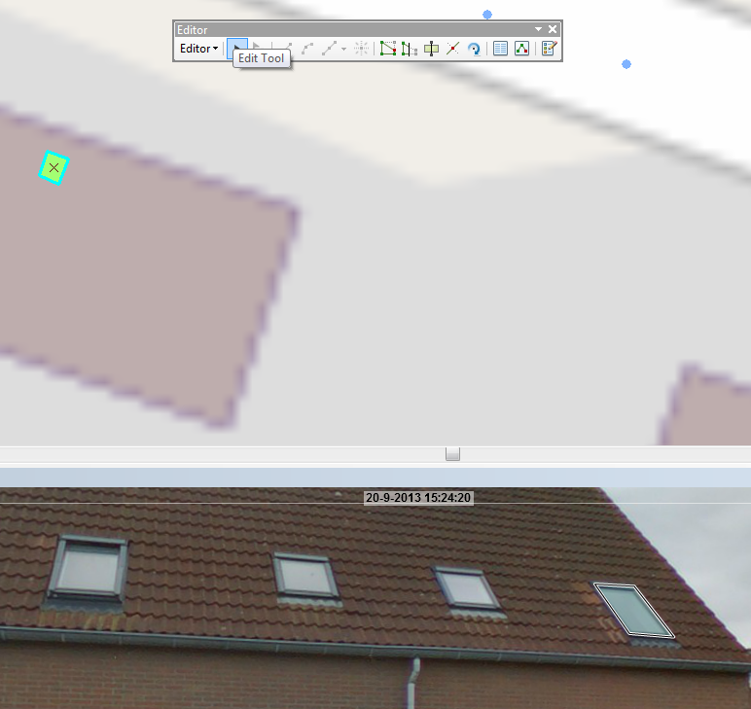Select the 'Edit tool’ button in the editor menu and a measurement can now be selected for import back into a cyclorama. (Figure 36)

Figure 36: Editor menu

1. 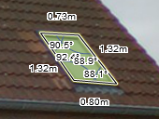Select a feature and the Measurement is placed back in the cyclorama. (Figure 37)

Figure 37: Measurement in cyclorama

1. Click on the feature and on the right mouse button and select in the menu 'Edit Vertices' to edit the measurement in the cyclorama. (Figure 38)
2. 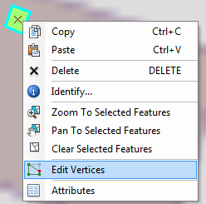It is now possible to edit the measurement in the cyclorama or in the map.

Figure 38: Select Edit Vertices

1. If you want to edit a measurement point in the cyclorama, select that point in the map.
2. 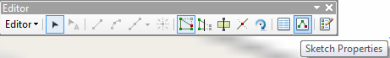Click in the ‘Editor’ menu on the ‘Sketch Properties’ button for view the values of the measurement points. (Figure 39)

Figure 39: Editor menu - Sketch properties

1. 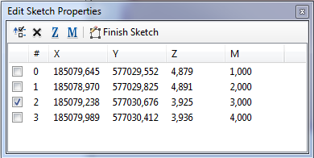You can change the measurement values by selecting a point. The M value is the reference to the number of that point in the cyclorama . (Figure 40)

Figure 40: Edit Sketch properties